**Devils Lake Transit  
Hours: 7:30 am to 4:30 pm  
Monday – Friday  
701-662-5061**

Place your ride reservation a day or more in advance. Same day service is available as the schedule allows.

If you have a ride scheduled and do not cancel it within 15 minutes of pickup time you will be charged for the ride.

Be ready 10 minutes prior to your scheduled time. If the driver has to wait longer 3 minutes you will be charged **$3 for a No Show.**

Fares: Have the correct fare when boarding the bus. **Charging is NOT** allowed. If the driver does not have change, a ticket will be issued instead of change.

After **3:30 pm,** requests for rides **will not** be honored.

The Bus **will not** go beyond John Deere or to the Dollar Tree and Walmart and beyond after 3:30 pm.

Riders shall conduct themselves in a courteous and respectful manner.

Passengers can bring with them on the bus only what they are able to carry on unassisted in one trip.

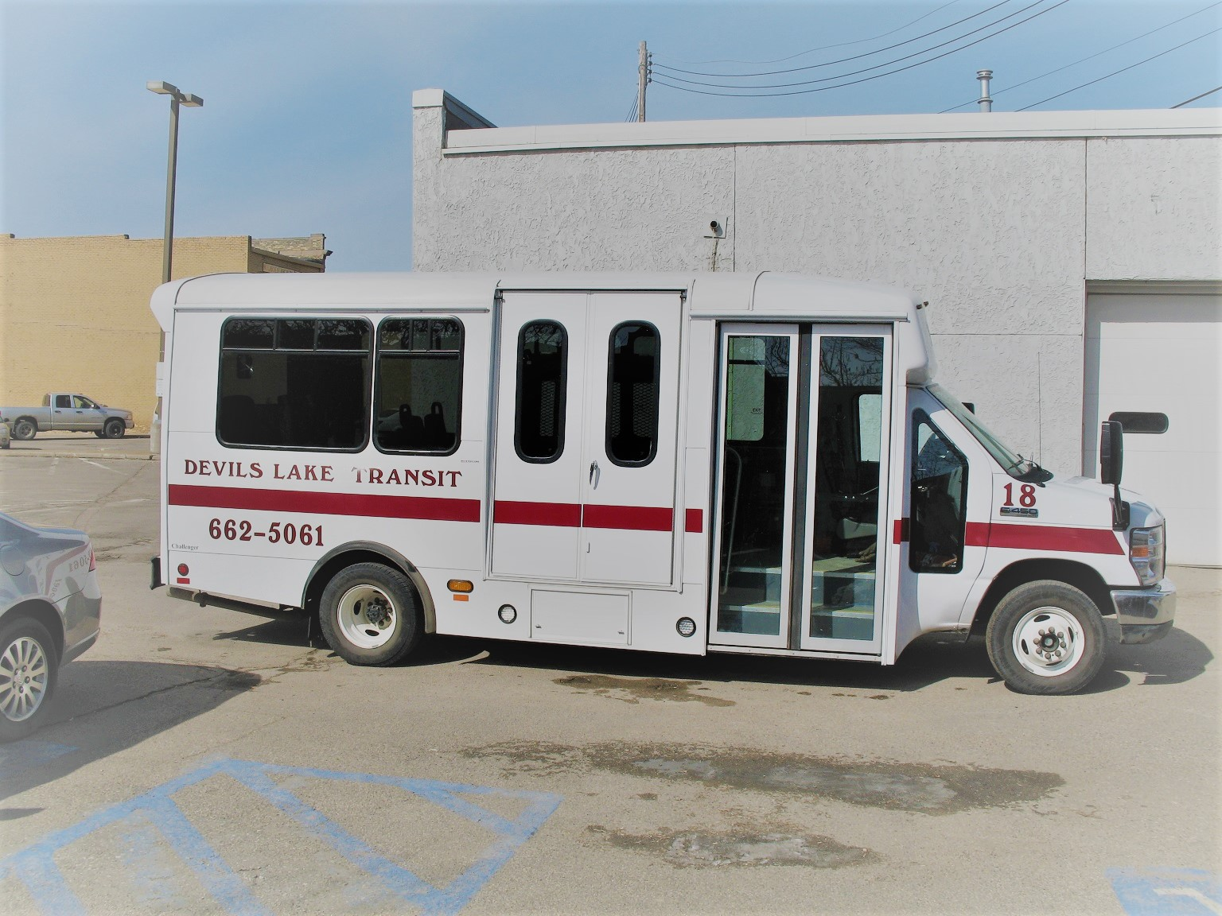

Animals other than service animals must be in pet carriers and are only allowed for veterinary visits for in-town service only.

White (10 Rides) Tickets and Pink (20 Rides) Tickets may be purchased form the driver, using cash or check. Reduced fare tickets (Blue) can only be purchased in the office and you must have a voucher to purchase a Blue Ticket.  
Suspension and/or the requirement of an escort may result if client is intoxicate, belligerent or any reason(s) that might harm or make it unsafe for any passenger, driver or vehicle.  
  
A copy of the “Rider Policy” is available by calling 701-662-5061.

Under Title VI of the Civil Rights Act of 1964, and its related statutes and regulations, no person or groups of persons shall be, on the grounds of race, color, or national origin be excluded from participation in, be denied the benefits of, or be otherwise subjected to discrimination under any and all programs or activities funded in whole or in part with Federal funds.

Devils Lake Transit will consider every request for reasonable accommodation from individuals with disabilities. Language assistance for Persons with limited English proficiency (LEP) is available free of charge. To request a reasonable accommodation or language assistance contact our office at (701) 662-5061, on our website at: www.seniormealsandservices.com, or in writing at 202 4th Ave NE; Devils Lake, ND 58301.